**Name:** Essam Eid Baiomy  
**B.N** :515  
**Date** : 5\6\2020  
**Topic**: Artificial Intelligence

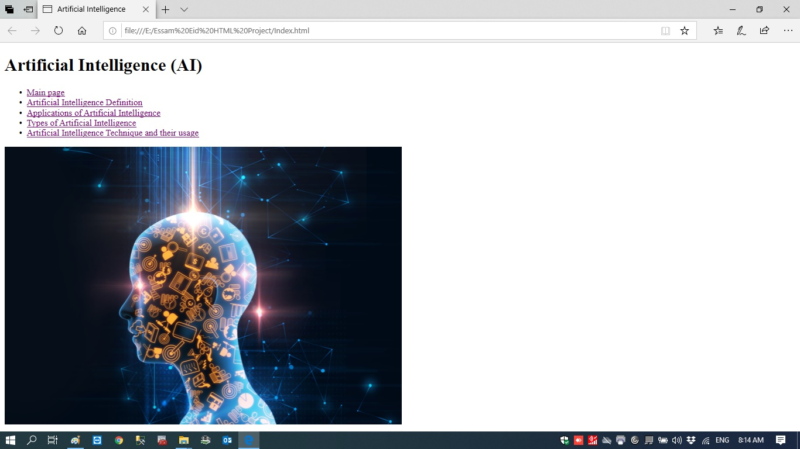**Artificial Intelligence Main Page:**

**Main Page Source code:**

<!DOCTYPE html>

<html>

<head>

<title>Artificial Intelligence</title>

</head>

<body>

<h1>Artificial Intelligence (AI)</h1>

<ul>

<li><a href="Index.html">Main page</a></li>

<li><a href="Artificial Intelligence Definition.html">Artificial Intelligence Definition</a></li>

<li><a href="Applications of Artificial Intelligence.html">Applications of Artificial Intelligence</a></li>

<li><a href="Types of Artificial Intelligence.html">Types of Artificial Intelligence</a></li>

<li><a href="Artificial Intelligence Techniques and their usage.html">Artificial Intelligence Techniques and their usage</a></li>

</ul>

<img src="AI image.jpg" alt="AI image" style="width:800

px;height:500px;">

</body>

</html>

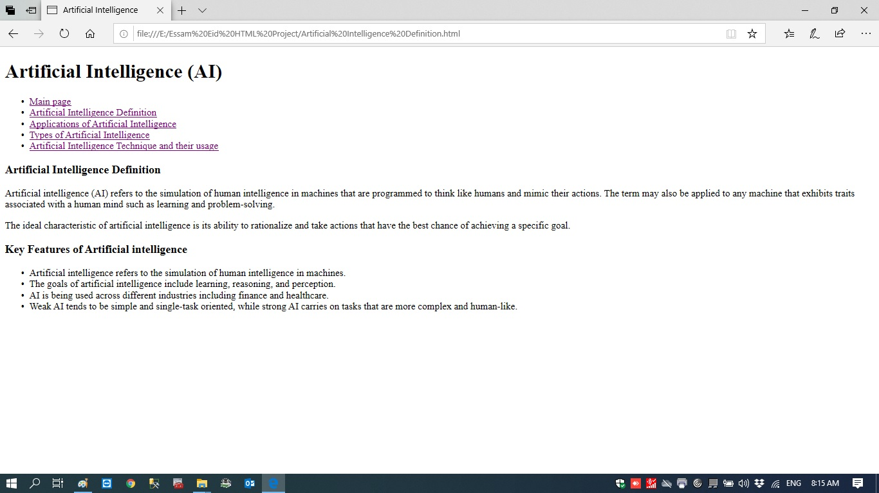**Artificial Intelligence Definition page:**

**Artificial Intelligence Definition source code:**

<!DOCTYPE html>

<html>

<head>

<title>Artificial Intelligence</title>

</head>

<body>

<h1>Artificial Intelligence (AI)</h1>

<ul>

<li><a href="Index.html">Main page</a></li>

<li><a href="Artificial Intelligence Definition.html">Artificial Intelligence Definition</a></li>

<li><a href="Applications of Artificial Intelligence.html">Applications of Artificial Intelligence</a></li>

<li><a href="Types of Artificial Intelligence.html">Types of Artificial Intelligence</a></li>

<li><a href="Artificial Intelligence Techniques and their usage.html">Artificial Intelligence Techniques and their usage</a></li>

</ul>

<h3>Artificial Intelligence Definition</h3>

<p>

Artificial intelligence (AI) refers to the simulation of human intelligence

in machines that are programmed to think like humans and mimic their actions.

The term may also be applied to any machine that exhibits traits associated

with a human mind such as learning and problem-solving.

</p>

<p>

The ideal characteristic of artificial intelligence is its ability to rationalize

and take actions that have the best chance of achieving a specific goal.

</p>

<h3>Key Features of Artificial intelligence</h3>

<ul>

<li>Artificial intelligence refers to the simulation of human intelligence in machines.</li>

<li>The goals of artificial intelligence include learning, reasoning, and perception.</li>

<li>AI is being used across different industries including finance and healthcare.</li>

<li>Weak AI tends to be simple and single-task oriented, while strong AI carries

on tasks that are more complex and human-like.</li>

</ul>

</body>

</html>

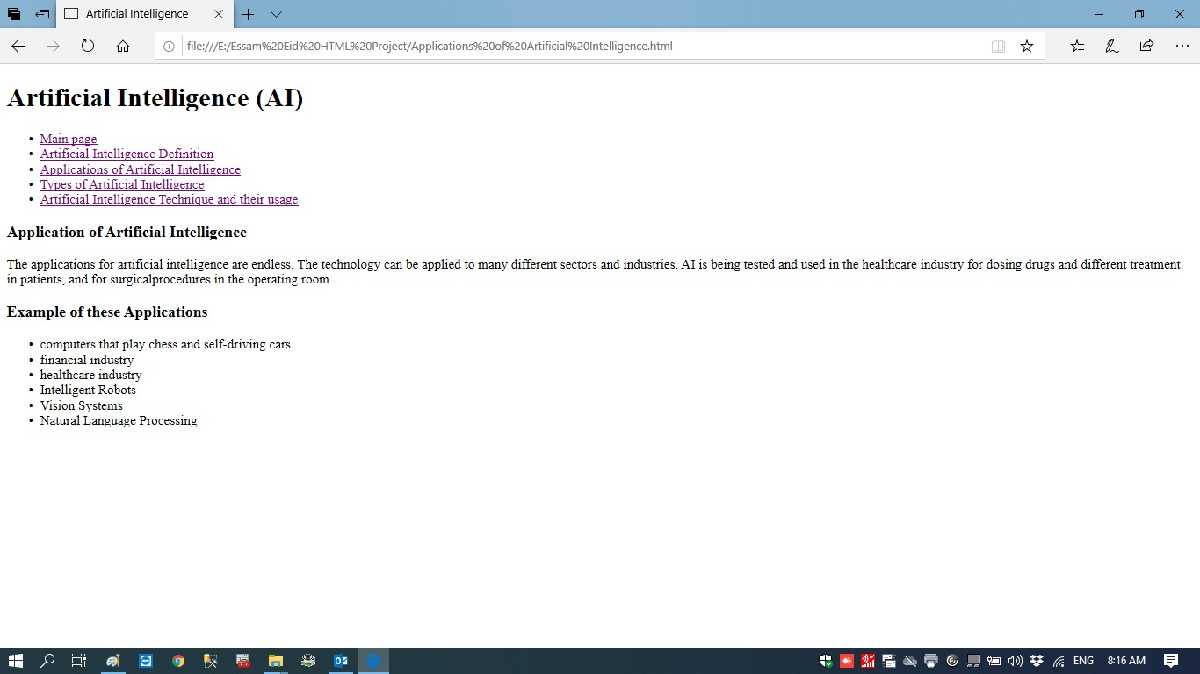**Applications of Artificial Intelligence page:**

**Applications of Artificial Intelligence source code**

<!DOCTYPE html>

<html>

<head>

<title>Artificial Intelligence</title>

</head>

<body>

<h1>Artificial Intelligence (AI)</h1>

<ul>

<li><a href="Index.html">Main page</a></li>

<li><a href="Artificial Intelligence Definition.html">Artificial Intelligence Definition</a></li>

<li><a href="Applications of Artificial Intelligence.html">Applications of Artificial Intelligence</a></li>

<li><a href="Types of Artificial Intelligence.html">Types of Artificial Intelligence</a></li>

<li><a href="Artificial Intelligence Techniques and their usage.html">Artificial Intelligence Techniques and their usage</a></li>

</ul>

<h3>Application of Artificial Intelligence</h3>

<p>

The applications for artificial intelligence are endless. The technology can be applied

to many different sectors and industries. AI is being tested and used in the healthcare

industry for dosing drugs and different treatment in patients, and for surgicalprocedures

in the operating room.

</p>

<h3>Example of these Applications</h3>

<ul>

<li>computers that play chess and self-driving cars</li>

<li>financial industry</li>

<li>healthcare industry</li>

<li>Intelligent Robots</li>

<li>Vision Systems</li>

<li>Natural Language Processing</li>

</ul>

</body>

</html>

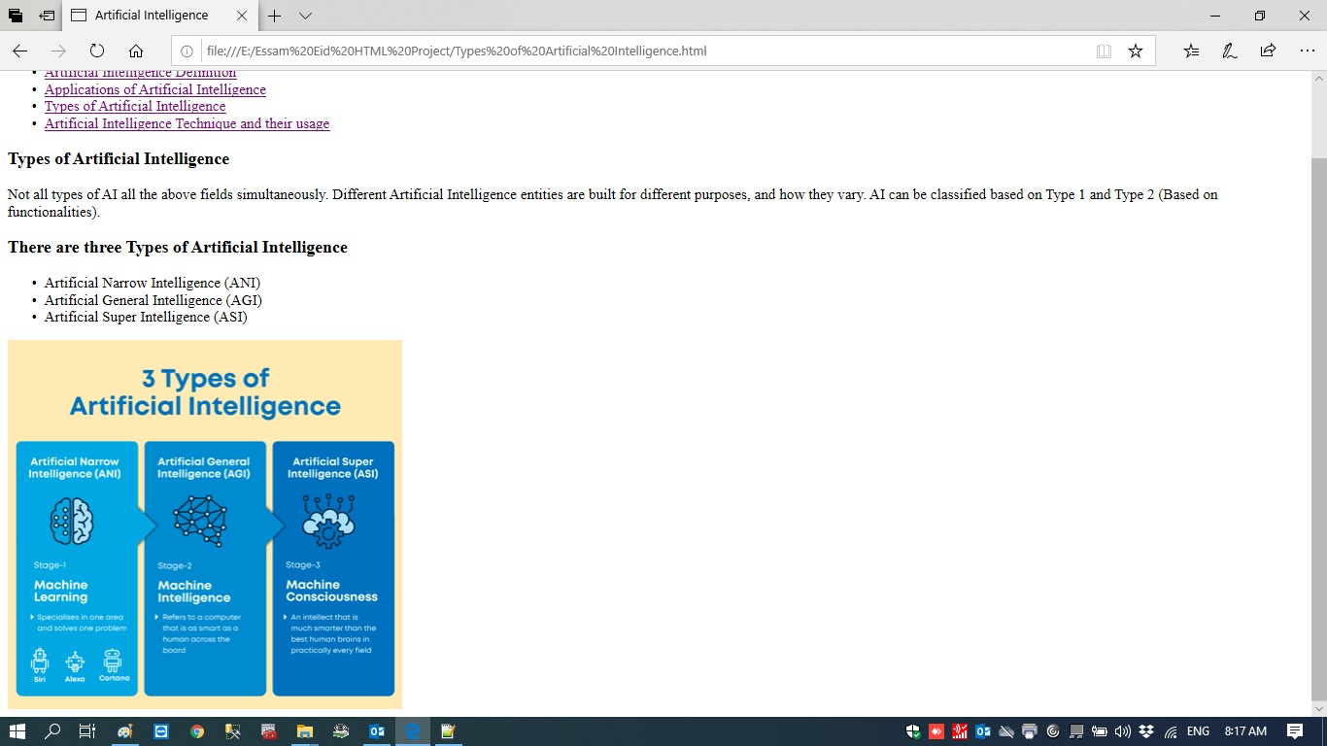**Types of Artificial Intelligence page:**

**Types of Artificial Intelligence source code**

<head>

<title>Artificial Intelligence</title>

</head>

<body>

<h1>Artificial Intelligence (AI)</h1>

<ul>

<li><a href="Index.html">Main page</a></li>

<li><a href="Artificial Intelligence Definition.html">Artificial Intelligence Definition</a></li>

<li><a href="Applications of Artificial Intelligence.html">Applications of Artificial Intelligence</a></li>

<li><a href="Types of Artificial Intelligence.html">Types of Artificial Intelligence</a></li>

<li><a href="Artificial Intelligence Techniques and their usage.html">Artificial Intelligence Techniques and their usage</a></li>

</ul>

<h3>Types of Artificial Intelligence</h3>

<p>

Not all types of AI all the above fields simultaneously. Different Artificial

Intelligence entities are built for different purposes, and how they vary.

AI can be classified based on Type 1 and Type 2 (Based on functionalities).

</p>

<h3>There are three Types of Artificial Intelligence</h3>

<ul>

<li>Artificial Narrow Intelligence (ANI)</li>

<li>Artificial General Intelligence (AGI)</li>

<li>Artificial Super Intelligence (ASI)</li>

</ul>

<img src="Types-of-Artificial-Intelligence.jpg" alt="Types-of-Artificial-Intelligence" style="width:1000

px;height:400px;">

</body>

</html>

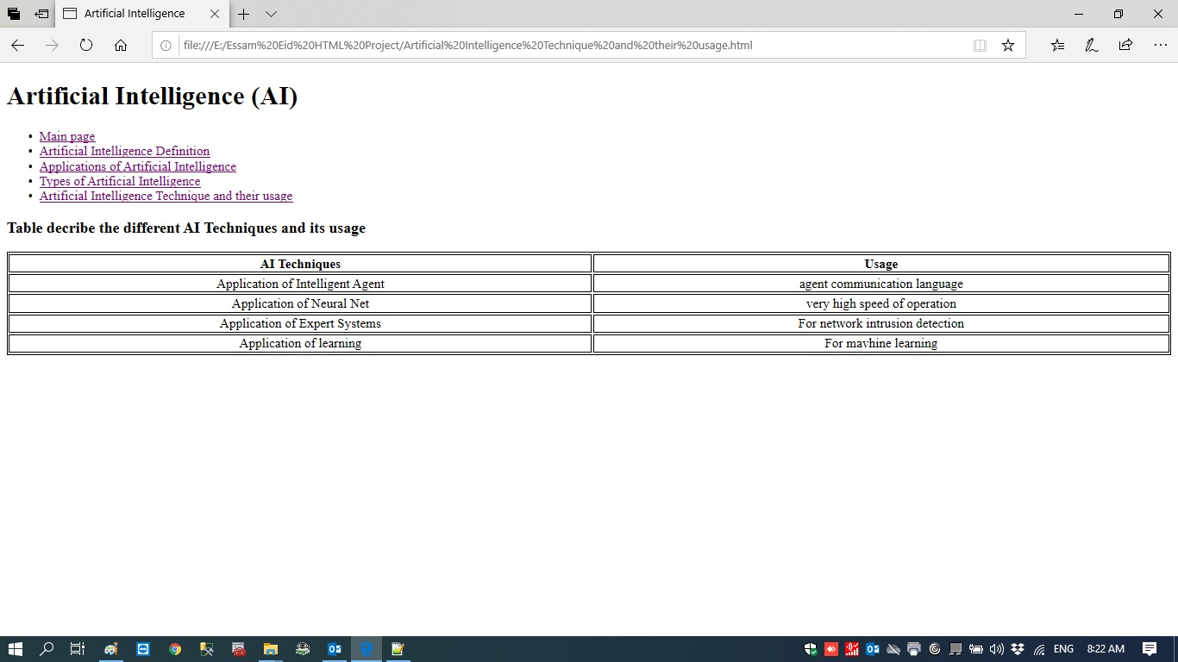**Artificial Intelligence Techniques and their usage page:**

**Artificial Intelligence Techniques and their usage source code:**

<!DOCTYPE html>

<html>

<head>

<title>Artificial Intelligence</title>

</head>

<body>

<h1>Artificial Intelligence (AI)</h1>

<ul>

<li><a href="Index.html">Main page</a></li>

<li><a href="Artificial Intelligence Definition.html">Artificial Intelligence Definition</a></li>

<li><a href="Applications of Artificial Intelligence.html">Applications of Artificial Intelligence</a></li>

<li><a href="Types of Artificial Intelligence.html">Types of Artificial Intelligence</a></li>

<li><a href="Artificial Intelligence Techniques and their usage.html">Artificial Intelligence Techniques and their usage</a></li>

</ul>

<h3>Table decribe the different AI Techniques and its usage</h3>

<style>

table, th, td {

border: 1px solid black;

}

</style>

<table style="width:100%">

<tr>

<th>AI Techniques</th>

<th>Usage</th>

</tr>

<tr style="text-align:center">

<td>Application of Intelligent Agent</td>

<td>agent communication language</td>

</tr>

<tr style="text-align:center">

<td>Application of Neural Net</td>

<td>very high speed of operation</td>

</tr>

<tr style="text-align:center">

<td>Application of Expert Systems</td>

<td>For network intrusion detection</td>

</tr>

<tr style="text-align:center">

<td>Application of learning</td>

<td>For mavhine learning</td>

</tr>